

Savitribai Phule Pune University
Modern Education Society’s College of Engineering, Pune
19, Bund Garden, V.K. Joag Path, Pune 411001.

ACCREDITED BY NAAC WITH A GRADE (CGPA 3.13)

DEPARTMENT OF COMPUTER ENGINEERING

A REPORT ON

“Fruit Detection using Machine Learning”

S.E. (COMPUTER)

SUBMITTED BY

Student Name:

Ekta Chaugule

UNDER THE GUIDANCE OF

PROF. GUIDE NAME: Dr. Shalaka Deore

(Academic Year: 2020-2021)

Savitribai Phule Pune University
Modern Education Society’s College of Engineering, Pune
19, Bund Garden, V.K. Joag Path, Pune 411001.

ACCREDITED BY NAAC WITH A GRADE (CGPA 3.13)

DEPARTMENT OF COMPUTER ENGINEERING

Certificate

This is to certify that PBL entitled

PBL Report
has been completed by Miss. Ekta Chaugule of SE COMP __ in the Semester - II of academic year 2020-2021 in partial fulfillment of the Second Year of Bachelor degree in ”Computer Engineering” as prescribed by the Savitribai Phule Pune University.

Prof Guide Name PBL Guide
(Dr.(Mrs.) N. F. Shaikh) H.O.D

Place: MESCOE, Pune.
Date: / /2021
ACKNOWLEDGEMENT

It gives me great pleasure and satisfaction in presenting this PBL on Fruit Detection using machine learning

I would like to express my deep sense of gratitude towards my PBL guide Dr .Shalaka Deore for her support, continuous guidance and being so understanding and helpful throughout the PBL.

I have furthermore to thank Computer Department HOD Dr.(Mrs.) N. F. Shaikh to en- courage me to go ahead and for continuous guidance. I also want to thank Dr.(Mrs.) A. P. Kale for all her assistance and guidance for preparing report.

I would like to thank all those, who have directly or indirectly helped me for the comple- tion of the work during this PBL-II project.

Ekta Chaugule
S.E. Computer

Introduction

- We will build a simple form of Fruit Recognition System. Although the example we’ll use is very simple, it reflects many of the same key machine learning concepts that go into building real-world commercial systems.

- The Machine will be able to recognize the fruits as per the data provided, accurately.

- We have imported the required libraries and the data of one fruit is being subdivided for better accuracy.

Literature Survey

- https://ieeexplore.ieee.org/document/9690537

- https://ieeexplore.ieee.org/document/7915033

- We have done some study in these papers before implementing our actual
project.

- These papers helped us a lot for getting into our final idea.
Motivation

- Sorting of similar type of fruits, while storing in a warehouse. Example- Tangerine and Orange.

- Mentally challenged people would easily differentiate between fruits.

- In the field of agriculture and food processing, quality evaluation is a significant parameter to increase benefits and accommodations for individual life.
- The presence of diseases and pesticides is additionally the major factor that emerges the need for quality evaluation. Although it can be done manually, some inconsistencies and high costs

OBJECTIVE

- Getting Information about the given fruits.
- Making the AI better with more fruit data processing.
- Also helping people in distinguishing between fruits.

METHODOLOGY
K-Nearest Neighbour is one of the simplest Machine Learning algorithms based on Supervised Learning technique. K-NN algorithm assumes the similarity between the new case/data and available cases and put the new case into the category that is most similar to the available categories.
- K-NN algorithm stores all the available data and classifies a new data point based on the similarity. This means when new data appears then it can be easily classified into a well suite category by using K- NN algorithm.
- K-NN algorithm can be used for Regression as well as for Classification but mostly it is used for the Classification problems.
- K-NN is a non-parametric algorithm, which means it does not make any assumption on underlying data.
- It is also called a lazy learner algorithm because it does not learn from the training set immediately instead it stores the dataset and at the time of classification, it performs an action on the dataset.
- KNN algorithm at the training phase just stores the dataset and when it gets new data, then it classifies that data into a category that is much similar to the new data.
- Example: Suppose, we have an image of a creature that looks similar to cat and dog, but we want to know either it is a cat or dog. So for this identification, we can use the KNN algorithm, as it works on a similarity measure. Our KNN model will find the similar features of the new data set to the cats and dogs images and based on the most similar features it will put it in either cat or dog category.

Flowchart..
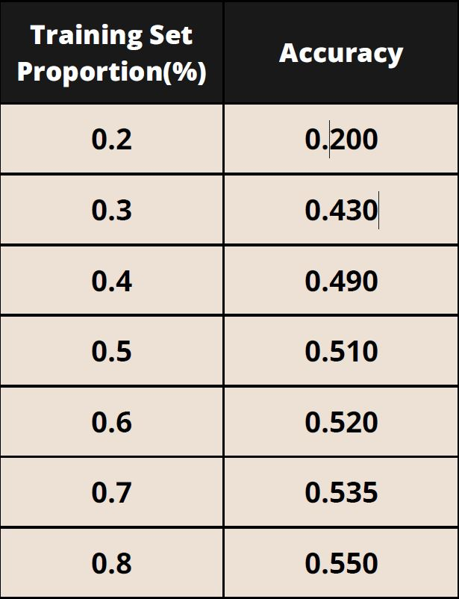
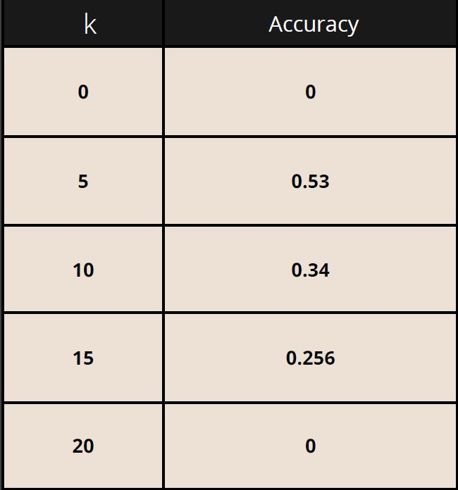
SOFTWARE AND HARDWARE REQUIREMENTS

SOFTWARE: Windows 10 or above/ Ubuntu 20.02
Python 3.7.0 or above.

HARDWARE: Intel quad-core CPU
4 GB Ram
10 GB free space
Monitor, Keyboard, Mouse
Results

Conclusion

This program is build on the KNN algorithm (K- Nearest Neighbour ) which helps in
the detection of the fruit or vegetable by scanning the image of the fruit. This
program is mainly built to differentiate between different kind of the fruit and also
to retrieve information of the given fruit including the name and biological facts of the fruit.

Future Scope
- Now you might think fruit prediction is a silly and impractical scenario. And given the
limited nature of this dataset, it is a bit of a toy example. But food companies do now rely
on machine learning systems that aren’t all that different in concept from the ones we’re
about to build, so they can do Automated Quality Control.
For example, real systems used by fruit shipping companies that screen for rotten oranges
during processing. Now the features they use in building these systems are a little more
sophisticated than the ones we did in this example.
- Quality control systems for rotten orange detection use ultraviolet light that can detect
interior decay, which is often less visible than just by looking on the surface.
From above points, we can conclude that there is future scope for this.
r ) which helps in the detection of the fruit or vegetable by scanning the image of the fruit.
- This program is mainly built to differentiate between different kind of the fruit and also to retrieve information of the given fruit including the

REFERENCES

https://www.c-sharpcorner.com/article/a-simple-classification-techniques-onfruit-dataset/

https://medium.com/swlh/fruit-classification-with-k-nearest-neighbors-191cf0497036

https://ieeexplore.ieee.org/document/9065747

https://ieeexplore.ieee.org/document/9690537

https://ieeexplore.ieee.org/document/791503

